Adjusting to Vision Loss
Vision loss, whether temporary or ongoing, brings challenges. You don’t have to face them alone.
Many individuals and families have walked this path and are here to support you.

A Community That Understands
If you or a loved one is experiencing vision loss, help is available. Accessing resources isn’t giving up; it’s a courageous step toward maintaining independence and thriving.

Inclusion starts with awareness. Barriers often stem not from blindness but from misunderstanding.

A simple "hello" creates connection, acknowledges presence, and fosters inclusion. Without it, those with vision loss miss out on everyday social cues.

Together, we can ensure blindness is understood, not isolating.

Tips for Maintaining Independence
- Leverage Technology:
Accessibility features on smartphones and computers can keep you connected and informed.

Explore Reading Options:
Audiobooks, large print, and Braille materials make reading accessible to all.

Get Training:
Organizations provide assistive technology training and other activities tailored for those with vision challenges.

Veterans’ Support:
Veterans can access specialized services and training through the VA, regardless of the cause of vision loss.

Our Mission

Since 1925, Lions Clubs International
has honored Helen Keller’s challenge to be “Knights Of The Blind,” preventing blindness and supporting those with vision loss.

In 2020, the Lions Knights of the Blind (KOTB) Committee was formed in Washington, Northern Idaho, and
British Columbia to expand access, inclusivity, and technology for individuals who are blind or have low vision.

How You Can Help
- Share this brochure with family, friends, and eye care professionals.
- Raise awareness about resources that promote independence.
- Help build an inclusive community where people with vision loss can thrive.
Together, we can shine a light on abilities, resources, and opportunities.

Your Questions Matter You may be asking:
- How will I get around if I can’t drive?

- Can I still live independently?

- How do I use my phone or computer effectively?

Take the Next Step – Explore these Resources!
MD19 Lions Knights Of The Blind www.MD19KOTB.org
BillScholl134@gmail.com 360-520-6802
Colette.Arvidson@gmail.com 360-391-5880

Local & National Resources
WA Department of Services for the Blind & Independent Living Program www.dsb.wa.gov
800-552-7103
Idaho Commission for the Blind & Visually Impaired www.icbvi.idaho.gov
208-334-3220
WA Council of the Blind www.wcbinfo.org
800-255-1147
National Federation of the Blind - WA www.nfbw.org
425-823-6380
National Federation of the Blind of Idaho www.nfbidaho.org 208-345-3906
Hadley Helps
(Free vision-loss training) www.hadleyhelps.org
800-323-4238
WA Talking Book & Braille Library
www.wtbbl.org 800-542-0866
WA State School for the Blind www.wssb.wa.gov
360-696-6321
U.S. Veterans: Vision Impairment Service Team www.rehab.va.gov/blindrehab/ Amanda Widmer
206-764-2758
Together, we can navigate vision loss and maintain independence.
Reach out today!
KOTB.Outreach.v02.12.25

Even temporary
VISION LOSS

requires adjustments

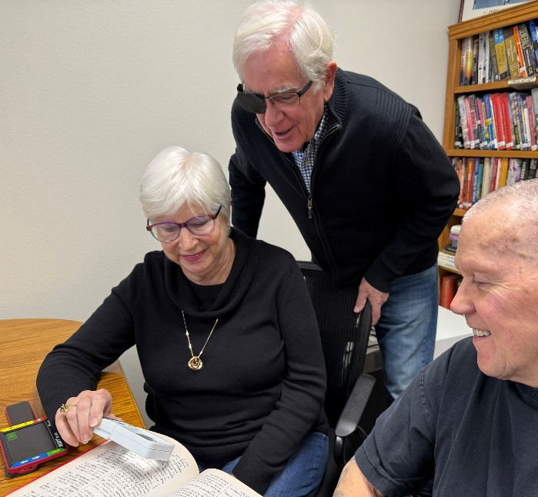

But you do
NOT

have to do this alone

